FONDAZIONE LEONE MORESSA
XII ANNUAL REPORT ON THE ECONOMICS OF IMMIGRATION
“ITALY OF THE RESELIENCE AND THE NEW ITALIANS”

Introduction
The “resilience” expression addresses to the capacity to resist a traumatic event by adapting to it and modifying one’s starting situation. It is also the key word of the post-pandemic economic recovery, characterized by the European investments of the Next Generation EU. In spite of the continuous uncertainties brought by the possible reverberations of the pandemic and the effects caused by the war in Ukraine, the planned investments should lead Italy to a more competitive and sustainable stance.
It is interesting to observe what the social effects in the medium term will be. The sanitary emergency has undoubtedly spurred inequalities, while underlying some latent fragilities. The previous Report had already underscored the extent to which immigrants have been the first to suffer from the repercussion of the pandemic on the occupational level, due to their higher levels of precariousness. Nevertheless, it is now vital to understand what role immigrants will play in the recovery and resilience process.
The Annual Report on the Economics of Immigration focuses on the analysis of social and economic dynamics related to the Italian immigration phenomenon. Beside the analysis based on data from official sources (for instance, among the main sources there are ISTAT, Eurostat, OECD, Ministry of Economy and Finance, Bank of Italy, Infocamere) the Report also presents, as customary, an in-depth analysis edited by experts and institutional representatives (among which: European Commission, International Organization for Migration, Ministry of Economy and Finance, Ministry of Labor and Social Policy, Confartigianato), thus providing a starting point for reflection and data interpretation.

- Social and demographic dynamics

The pandemic has participated in an already in-progress and significant national demographic change. The so-called “demographic winter”, as demographers address it, is a mix of low birth rate (which has furtherly been exacerbated), extension of life expectancy – with the consequent rise of the elderly cohort – work force emigration abroad and a series of other intertwined phenomena that have characterized the Italian national panorama of the last decades.
For instance, it is significant to witness that the natural growth rate (namely, the difference between births and deaths) was negative – by 300 thousand units – in 2021. The inflow of immigrant population, that in the last years has represented a valuable resource to counterbalance the demographic decline, is no longer enough. Indeed, in recent years, the figures of new arrivals have decreased and also birth rates have declined among foreign-born nationals.
Furthermore, in the last years, the composition of new arrivals has significantly changed, with increasingly less “planned” arrivals (employment-based admissions) and more and more “non-planned” entrances: EU citizens’ registrations, admissions on humanitarian grounds, family reunifications. This also changes the composition of the foreign population in Italy, which has now reached 9% of the total population, with peaks over 15% in many large cities in the Center-North.
The presence of over a million of “new Italians” is also not to be neglected. This expression indicates immigrants that are well integrated in the territory and have acquired the Italian citizenship.
Therefore, the figure of the immigrant population in Italy, which has now reached 5.2 million of residents, would further inflate if “foreign-origin Italians” and irregular immigrants are also considered, as they altogether reach a population of about 6 million. Nevertheless, the statistics consider to be “foreigners” those children (minors) born from foreign parents (about a million). These youths need to wait until their coming of age to be able to apply for the citizenship of the country where they were born and grew up.

- Immigration’s economic contribution in Italy

After the occupational crisis which took place in 2020 due to the pandemic (-3.1% of employed in Italy), in 2021, a slight increase was registered in employment rates (+0.8%).
In 2020, precarious workers were the most affected by the situation, as they were not sheltered by the so-called “dismissals suspension”. Among the most fragile categories of the labor market, women – and, more specifically, foreign women – were the most affected. It is enough to consider that foreign women, who represents the 4.2% of the work force, lost 16.3% of jobs (724 thousand), in 2020, due to the pandemic.

To date, the Italian labor market still appears strongly fragmented, as some sectors or occupations are characterized by a significant presence of immigrant workers. In fact, in 2021, the incidence of foreign laborers was on average 10% of the total of employees and figures stretched from 2.2% for skilled and technical professions to 29.2% for unskilled personnel.
Looking at the same occurrence from another perspective, almost a third of foreign workers (31.7%) performs an unskilled job, while this percentage is limited to 8.5% for Italian workers.
This leads the analysis to another topic, beside the one on social immobility: namely the “waste” of talents. In fact, many foreign workers find themselves tied to an unskilled occupation despite they hold a degree or have higher competences. This phenomenon (that is, “overeducation”), is more widespread among foreigners due to a series of factors: the lack of linguistic proficiency, a scarce knowledge of the territory, the necessity to have an occupation to renew the residence permit, and the lack of a family network that would allow to decline a job offer that does not correspond to one’s competences.
It is also worth of attention the Italian immigrant entrepreneurship phenomenon that counted 753 thousand foreign-born entrepreneurs (physical corporate office persons operating in companies in Italy) and 572 thousand foreign-guided enterprises by the end of 2021.
In the last ten years, while the figure of Italian-born entrepreneurs decreased by -8.6%, foreign-born entrepreneurs grew by +31.6%, thus representing a tenth of total entrepreneurs.
This phenomenon is marked by both lights and shadows: although the increase of foreign-lead enterprises might indicate an ongoing “integration” process in Italy, it is clear that in many cases such new foreign-owned companies are set in certain market segments characterized by low productivity and low value. In this way, such dynamics determines a “replacement from below” compared to previous businesses. The challenge for the whole national system is to be able to build synergies and exchanges between Italian and “foreign” enterprises, so to prompt a reciprocal and comprehensive growth.

- The fiscal impact of immigration in Italy

Lately, in Italy, even if the immigration phenomenon has received less media coverage, the idea that immigrants represent a cost rather than a benefit for the state coffers still runs rampant in public opinion.
The Ministry of Economy and Finance’s (MEF) data on 2021 tax return (t.y. 2020) allow to analyze the impact of immigrants’ component on the total of taxpayers and in this way to quantify the immigration’s tax contribution.
There are 4.17 million foreign-born taxpayers, with a tax declaration of 57.5 billion euros and paid Irpef amounting to 8.2 billion euros. The time series analysis promptly underscores the impact of the COVID-19 emergency: in 2020, for the first time, the figure of foreign-born contributors decreased (-1.8%), as well as the volume of tax return (-4.3%) and that of paid Irpef (-8.5%).

Among foreign-born taxpayers, almost half of them (48.7%) have declared to have an annual income of less than 10 thousand euros. Among the Italian-born contributors, the class of those with such an income is only 29.5% of the total taxpayers. Altogether, foreign-born contributors represent 10.1% of the total, displaying an incidence varying from 3.3% for those with an income range over 50 thousand euros to 15.7% for those with less than 10 thousand euros.

By comparing revenues and expenditures for public finances (respectively, taxes and contributions on the one side, and welfare services on the other), in 2021 (tax year 2020), the overall balance has further increased (+1.4 billion). Although foreign-born taxpayers’ declarations have declined, the expenditure for asylum seekers and refugees’ reception has also decreased. This does not surprise, considering the significant drop in asylum seekers and refugees’ applications in the 2015-2017 period.
In 2021, regular immigrant workers were 2.26 million, that is 10% of the total, whereas people received in reception centers were about 78 thousand (with a ratio of 30 immigrant workers per every received migrant).
The social security and welfare components importantly determined such a positive balance: given 8.4 billion expenditures (pensions, unemployment, etc.), 15.9 billion revenues are originating from social and security contributions.

It is vital to remember that such balance does not consider the contribution that the immigrant presence provides to the undergoing demographic dynamics and to the needs of the production system. Immigrants’ social inclusion will thus continue to offer benefits in the economic sphere, by ensuring a pool of workforce, a given level of consumption and new investments.

- The international panorama

Migration is, by definition, a process that involves (at least) two countries, one of origin and one of destination (to which should be added countries of transit, where most often migrants end up living for longer years).
Therefore, migration is an international process which has its effects both on countries of destination (at the demographic, economic and social level, as illustrated by this Report) but also on countries of origin.
In particular, the nexus between migration and development is further validated by the UN Agenda 2030 for Sustainable Development. Within this new paradigmatic framework, where sustainable development is envisaged at the global level, all countries are appealed to embrace the 17 Objectives, regardless of their latitude, income level and geo-political classification. Such an approach contributes to challenge the more traditional and dichotomic discourse around the migration-development nexus, which is polarized between push and pull factors in a most often unidirectional way from the global South to the global North.

“Remittances”, namely money flows destined to families in one’s home country, represent one of the means through which migrants contribute the most to the development of their country of origin.

By considering only money flows sent from Italy, remittances have displayed a continuous increase since 2017. The overall reported volume is 7.7 billion euros, close to its highest peak of 8 billion registered in 2011.
In particular, in 2021, remittances increased by 12.2% compared to the previous year, and by 46.3% compared to 2016. The incidence on GDP is registering a rise, too. After exceeding the 0.4% quota, between 2009 and 2012, the balance between remittances and GDP declined below 0.3% in 2017. Since then, the figure has been showing a constant increase, with the current value being 0.44%.

During the pandemic, although the decrease in available income, immigrants have maintained, if not increased, the support to their families in countries of origin.
This rise can be explained by several elements. For instance, in periods when international mobility was no longer an option, sending money home was the only possible way to support one’s family. As a matter of fact, the highest increases were registered for those countries that are usually more easily reachable, such as East Europe and North Africa.
Moreover, countries of origin, too, have suffered from the consequences of the pandemic, thus asking their emigrants for a greater effort in terms of economic support.

- Integration and perception

The “integration” concept can be subject to different declinations and interpretations. In the “Integrated multi-annual work, integration and inclusion programming 2021-2027”, the Ministry of Labor and Social Policies identifies seven main courses of action: 1) cooperation among actors of integration; 2) dignified labor; 3) social and working placement for vulnerable immigrants; 4) youths and workers’ potential; 5) immigrant women; 6) participation, culture and sport; 7) legal entrance channels.

Today, school is one of the loci where integration plays a pivotal role, as we can find 877 thousand students with a non-Italian citizenship (10.3% of the total). Among them, 65% are born in Italy but are considered “foreigners” due to the current Law on citizenship, dating back to 1992.

In Italian cities, especially in Center-North, multiethnicity is already a fact: the steady presence of immigrants and their integration in the productive and economic system prove that the concretization of a “melting pot” has anticipated any legislative initiative.
Nevertheless, strong inequalities and discriminations still persist, as proven by the consumption patterns and expenditure capacities.

Conclusions

In 2021, Italy registered a rise of residence permits and, in particular, of working permits, which stretched from about 10 thousand in 2020 to over 50 thousand. In relative terms, too, working permits went from 9.7% to 18.5% of the total issued permits. Although family reunification permits embody the most consistent component, the increasing figure of working permits are a tell-tale sign regarding the needs of the national productive sectors.

Lastly, the undergoing war in Ukraine has on Italy needs to be observed from different perspectives. There are issues such as the refugees’ reception and their settling down in the territory. With an already sizeable presence of Ukrainian citizens (236 thousand in 2021, of whom almost 80% women), Italy has been one of the most responsive countries in the first phase of the emergency as it received more than 120 thousand people fleeing from the conflict area from February to May 2022.
However, this first phase has been mainly managed by the effort of third-sector associations and Ukrainian citizen residing in Italy. Thus, it will be necessary to rethink the Italian reception system in order to prevent the criticalities experienced in 2016 and 2017. It is imperative to look at the “after-reception” process, so to delineate social integration and inclusion trajectories and, where deemed advisable, repatriation.
One of the challenges for Italy will be to devise and inclusive recovery to reduce inequalities (related not only to citizenship but also to gender, age, and physical condition) instead of spurring them. In this way, the Next Generation EU will truly become more sustainable and welcoming.
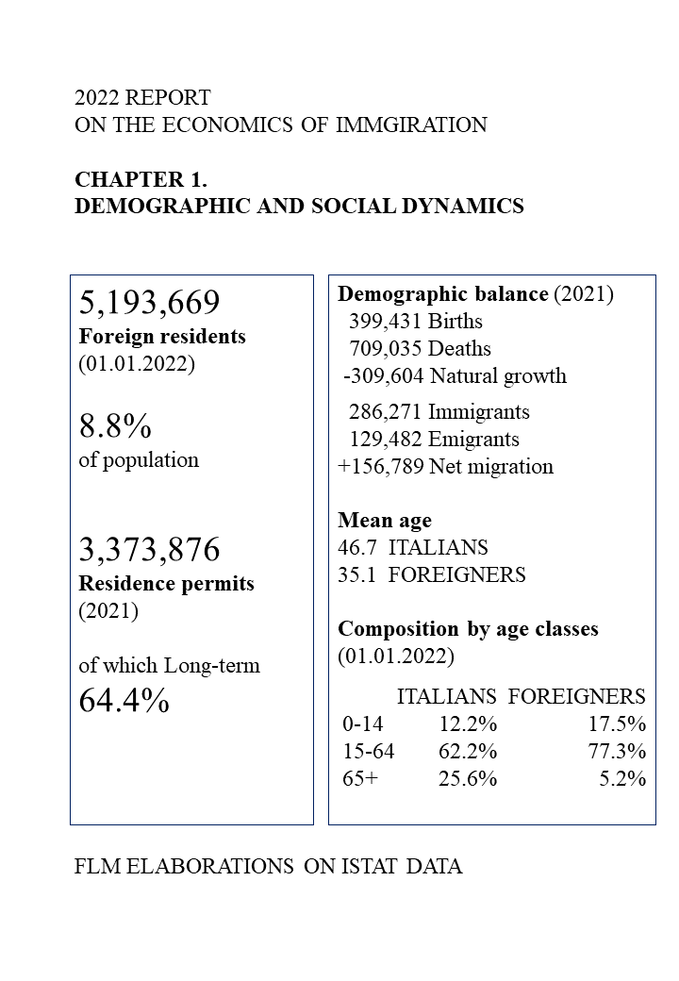
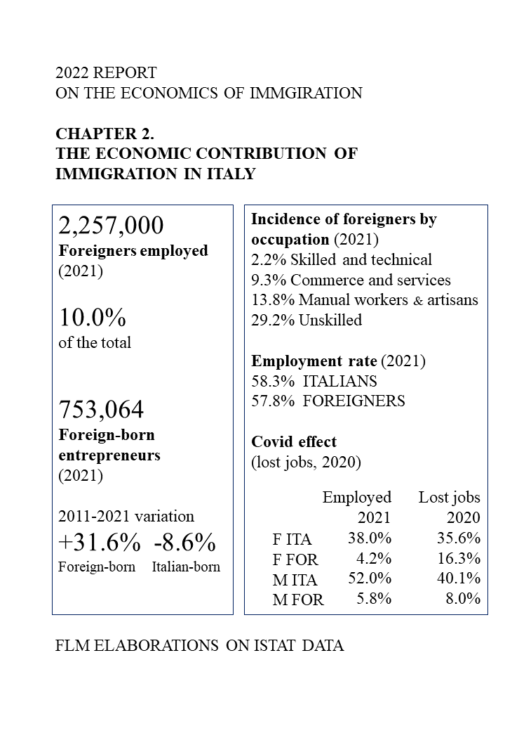
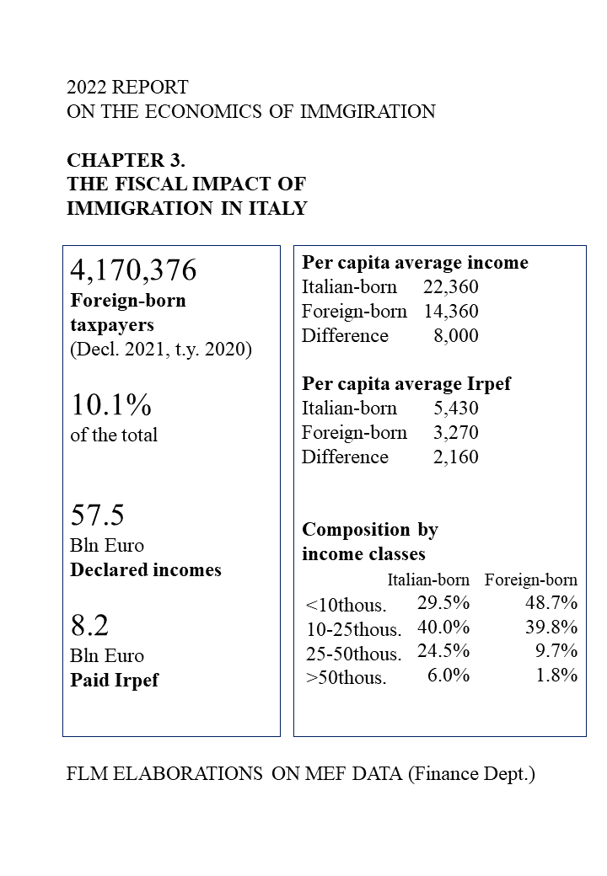
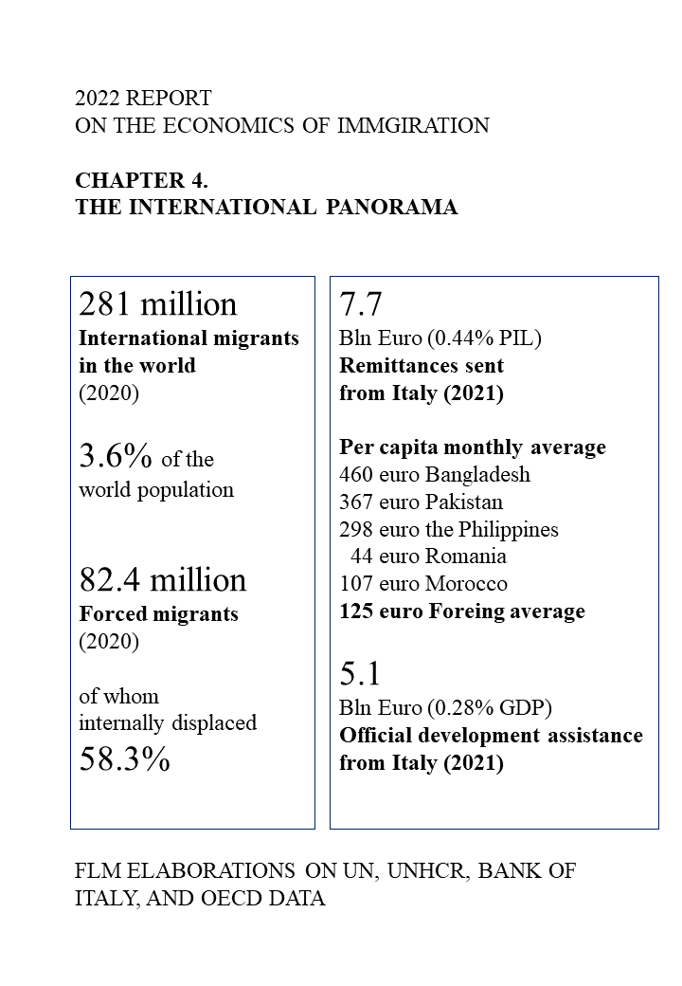
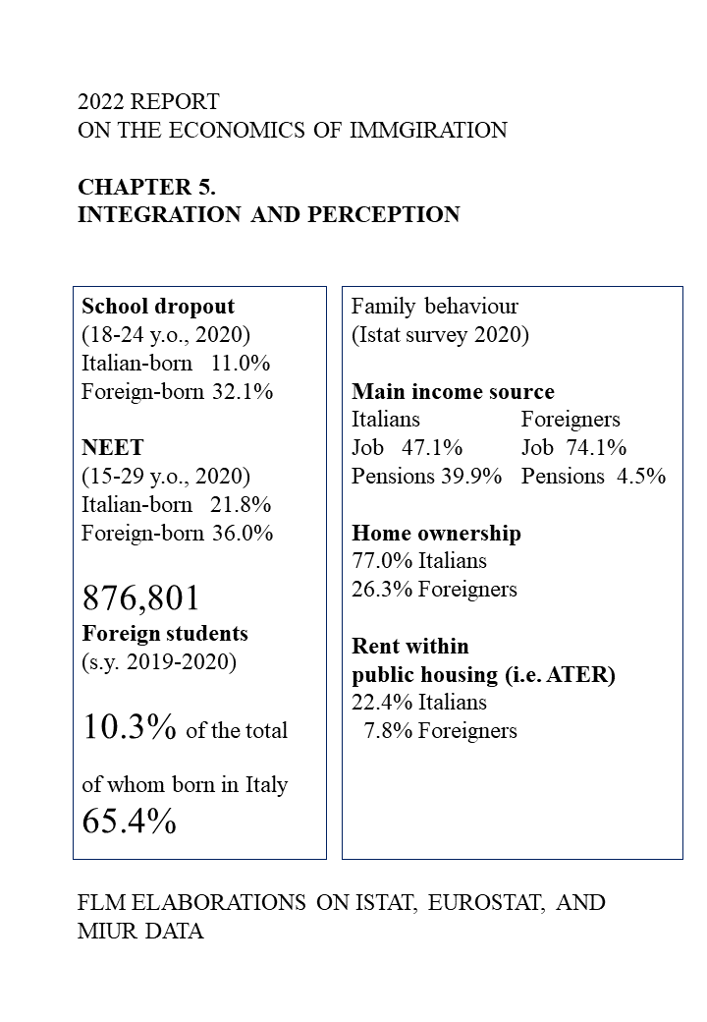

Programmazione integrata pluriennale in tema di lavoro, integrazione e inclusione 2021-2027.

